**Issues and Challenges Faced**

1. Unable to write the stats into influxDB

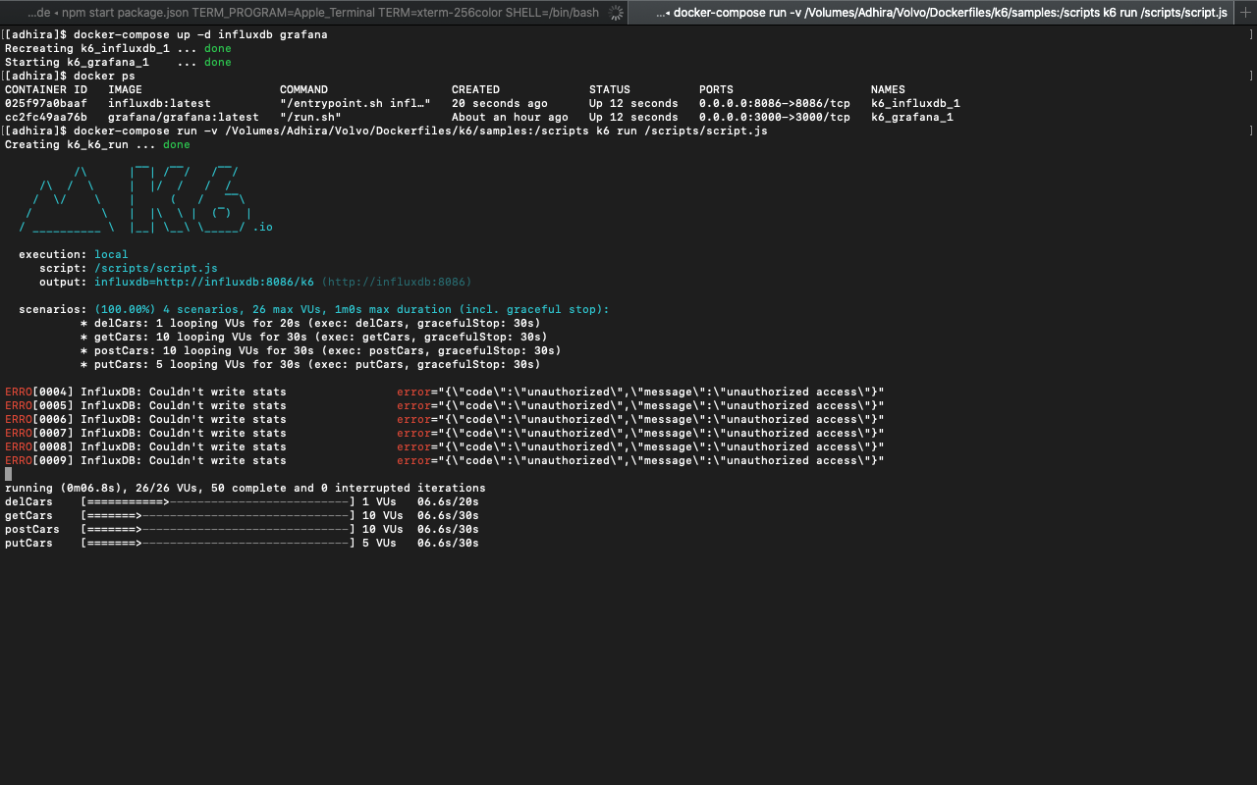

**Reason:** Based on my research, the latest docker image of influxDB is not suitable with K6 docker image. Hence, its unable to send the metrics to influxDB and giving unauthorization error message.

**Solution:**

We need to update the docker-compose.yaml file pointing the influxdb image to 1.8 version.

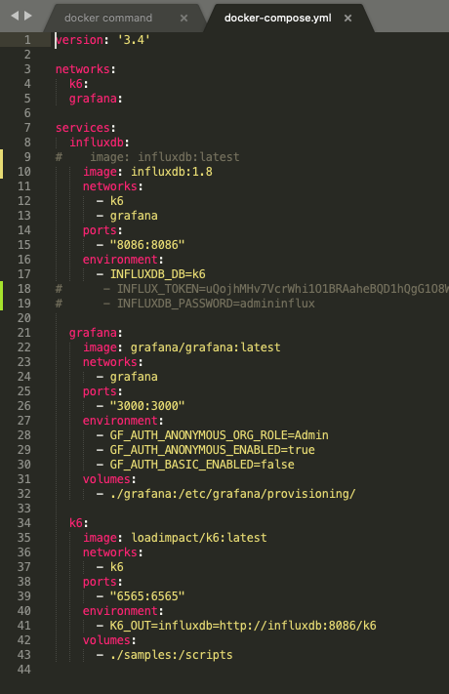

1. Connection refused error (http://localhost:8086/api/cars) while running it in docker container

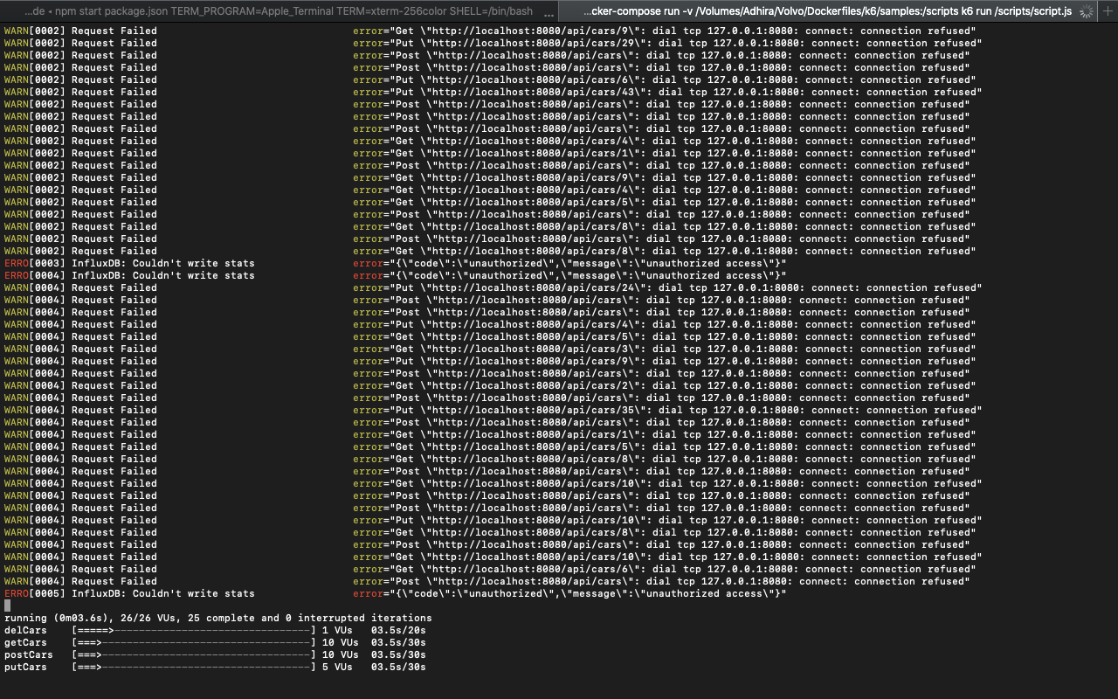

**Reason:** URL for localhost is different when it is running in docker container.

**Solution:**

We need to update the URL as “host.docker.internal” instead of localhost in the script.

